Garw Valley Community Council
PO Box 377
Bridgend
CF31 9PS

Tel/ Ffôn:
07944673642
E-mail/E-bost: clerkgarwvalleycc@gmail.com
Website/Gwefan:
www.gvcc.org.uk

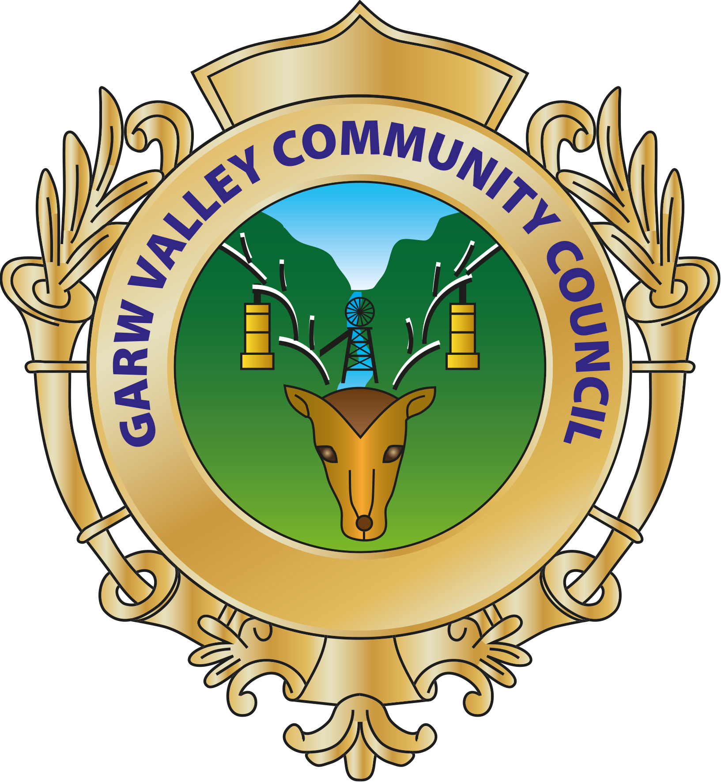

15th January 2019
To: All Garw Valley Councillors

You are hereby summoned to attend the Ordinary Meeting of the Garw Valley Community Council at 6.30 pm on Monday 21st January 2019 to be held at Blaengarw Workmen’s Hall for the purpose of transacting the following business.

The Press and Public are welcome to attend.

Agenda Ordinary Meeting

- To receive Apologies for Absence
- To receive Declarations of Interest
- To elect a Chair
- To receive the South Wales Police/Crime Figures
- To read, consider and approve Minutes of the January 2019 Precept Meeting
- To consider matters arising from the January 2019 Precept Meeting Minutes
- Borough Council Updates and Ward Reports
- Friends of Parc Calon Lan
- Upper Garw Valley Workshop
- Acknowledging LGBT Month as a Council
- Working with Schools on Council Projects
- 3 Year Strategy – going forward
- To receive an Employment Committee Update and Recommendations
- Finance & Accounts incl. recommendations from Finance Committee
- Chair’s Report
- Clerk’s Report
- Correspondence
- Planning Matters
- To discuss Staff Confidential Matters (Public to be excluded)
- Items for the February 2019 Ordinary Meeting
- Date & Venue for the next Meeting Blaengarw Workmen’s Hall at 6.30 pm on Monday 18th February 2019

Ann C. Harris
Clerk of the Council
Clerc y Cyngor

