Ann C. Harris
Garw Valley Community Council
PO Box 377
Bridgend
CF31 9PS

Tel/ Ffôn:
07944673642
E-mail/E-bost: clerkgarwvalleycc@gmail.com
Website/Gwefan:
www.gvcc.org.uk

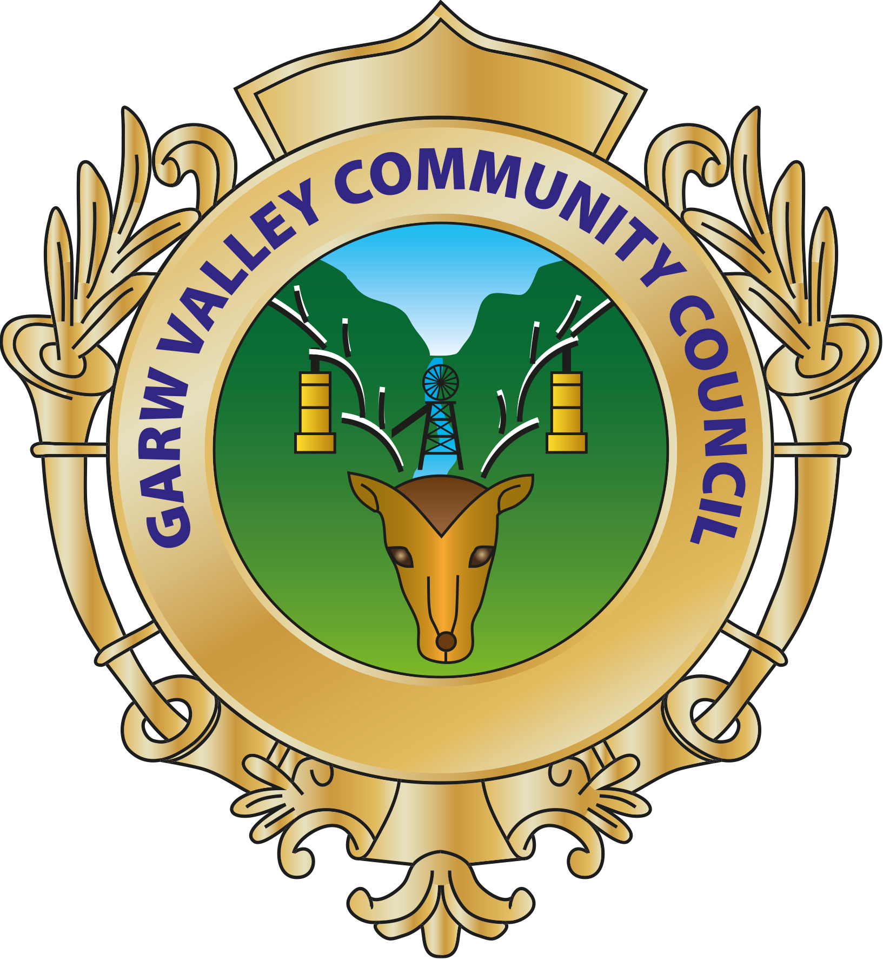

29th November 2019

Dear Councillor,
You are hereby summoned to attend a Finance & Resources Committee Meeting of the Garw Valley Community Council to be held at 7.00 pm on Wednesday 4th December 2019 at 7.00 pm for the purpose of transacting the following business.
Yours sincerely,

Ann C. Harris
Clerk & RFO

Members are reminded that they attend this Meeting under the provisions of the
Community Council’s Code of Conduct

AGENDA

- To receive apologies for absence

- To receive declarations of personal and prejudicial interest, if any, from Members in items on the Agenda

- To record the accuracy of the September 2019 Minutes of the Finance & Resources Committee Meeting.

- Matters Arising from the September 2019 Minutes

- To review the council’s budget and identify any potential risks

- To Draft a Precept for 2020/21

- Items for the next Finance & Resources Committee Meeting

- To agree the date and location for the next Finance and Resources Committee Meeting

