Garw Valley Community Council
PO Box 377
Bridgend
CF31 9PS

Tel/ Ffôn:
07949451690
E-mail/E-bost: clerkgarwvalleycc@gmail.com
Website/Gwefan:
www.garwvalleycc.co.uk

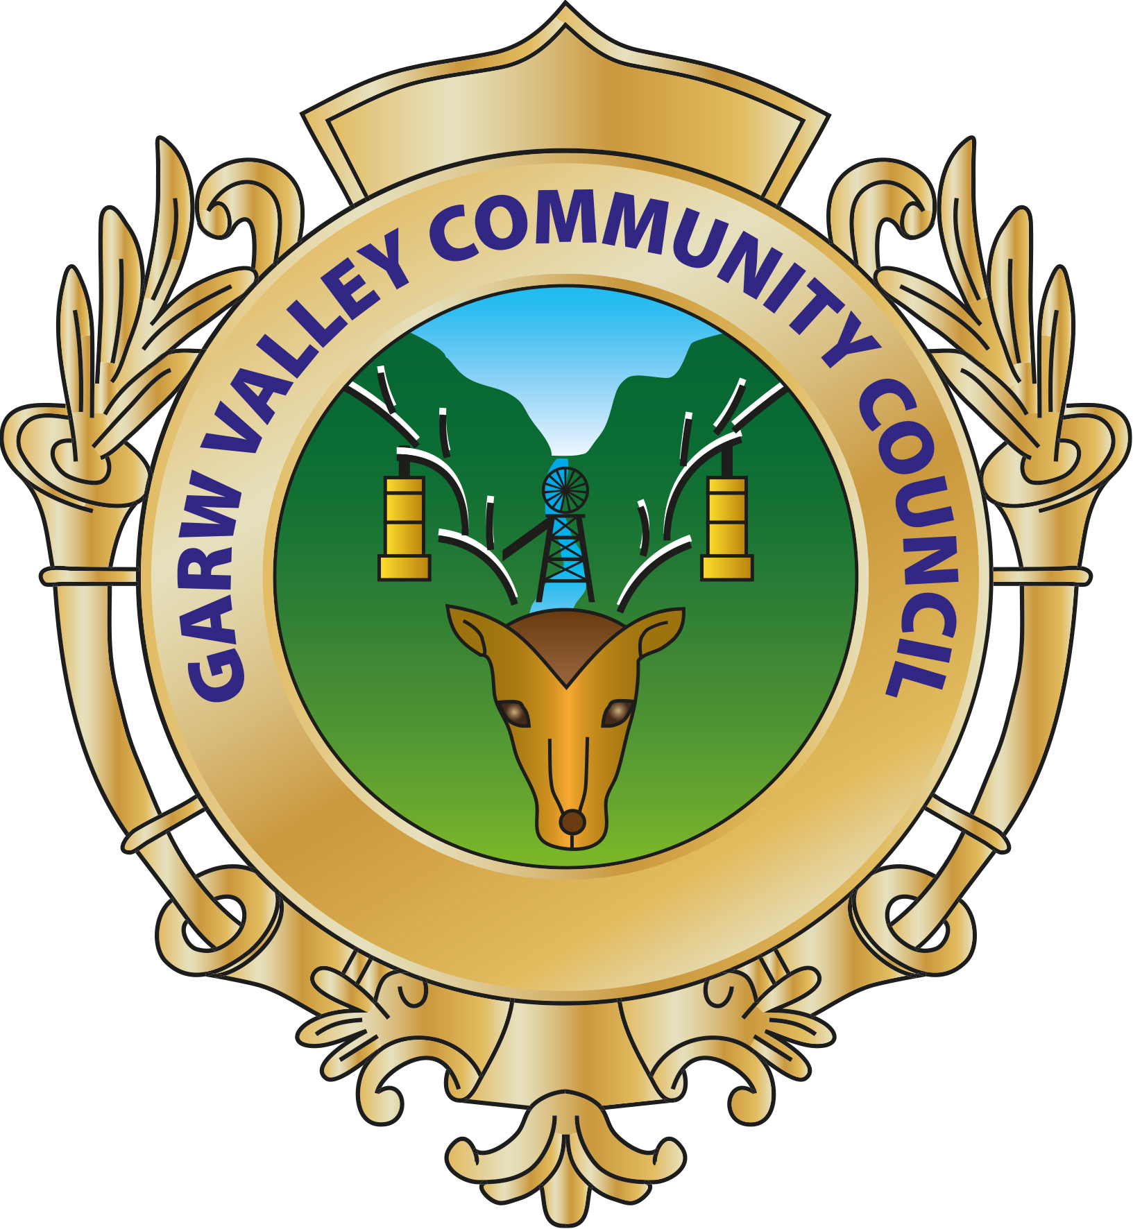

26th April 2023

Community Award 2022
The Community Council are running their annual Community Awards again this year and nominations are now being invited from the Community.
Nominations are open to all ages and are invited from any of our four wards – Bettws, Blaengarw, Llangeinor and Pontycymer.
This year we’ve got two awards. Nominees in the first category can be organisations, groups or individuals and can be nominated for any community activity such as culture, voluntary work, business achievements or work activities and can relate to a specific achievement or something that is of benefit to the community.
The second award is specifically for sport and includes those who participate in sport, coaches, managers, volunteers etc.
If you would like to submit an electronic nomination form please visit our website, if you would like a hard copy of the form to complete please request it from the Clerk by ringing the number above.
Nominations are to be received no later than midnight on
Friday 2nd June 2023
The winners will be notified after 19th June and will be invited to attend the Ordinary Community Council Meeting to be held on Monday 17th July 2023, to be presented with a shield in recognition of their achievement.

Ann C. Harris
Clerk of the Council/Clerc y Cyngor

